Index

|  |  |  |
| --- | --- | --- |
| Sr.no | Topic | Page No. |
| 1. | Introduction | 1 |
|  | 1.1 What is PHP | 2 |
|  | 1.2 Features of PHP | 2 |
|  | 1.3 Motivation | 3 |
| 2. | General Description | 4 |
|  | 2.1 Introduction | 5 |
|  | 2.2 Product Perspective | 5 |
|  | 2.3 General Constraints | 6 |
| 3. | Requirement Analysis and Specification | 7 |
|  | 3.1 Problem Solving Technique | 8 |
|  | 3.2 Project Life Cycle Model | 9 |
|  | 3.3 Advantages of Model | 10 |
|  | 3.4 Function Requirement of System | 11 |
|  | 3.5 SRS | 12 |
| 4. | Design | 13 |
|  | 4.1 Data Flow Diagram | 14 |
|  | 4.2 Entity Relationship Model | 18 |
|  | 4.3 Data Dictionary | 20 |
| 5. | Implementation and Testing | 22 |
| 6. | Graphical User Interface | 24 |
|  | 6.1 Application Interface | 25 |
| 7. | Conclusion and Future Work | 32 |
| 8. | Bibliography | 34 |

**Chapter-1**

**Introduction**

* 1. What is PHP
* PHP is an acronym for “Hypertext Pre-processor”
* PHP is free, and open source scripting language.
* PHP is a Server Side Scripting Language. Scripts are executed on Server.
* The result is returned to the browser as plain HTML.

## Features of PHP

* Generate Dynamic Page Content.
* Access and work with Files on Server.
* Send/ Receive Cookies.
* Access and Work with database.
* Encrypt Data
* Collect form Data.
* Restrict users from accessing without authentication.

Chapter-2

General Description

2.1 Introduction: -

* The Project “College website” is an innovative website of Dr. S. & S. S. Ghandhy College of Engineering & Technology.
* It is designed by implementing PHP, MySQL, HTML, CSS, JavaScript and JQuery, Ajax, and Bootstrap.
* Adobe Dreamweaver is used for Programming and Designing Tool.
* Mozilla Firefox and Google Chrome are used as Diagnostic Tools.
* The Website Provides dynamic college information such as Department Wise Staff Details, Placement details, Articles, Results, Syllabus, etc.
* It also provides Administration panel from where Admin can update/ Edit web content.
* This Website is a cross browser/cross device compatible, having interactive Graphics.
* The scope of the website is not only limited to attracting and encouraging high school students to take coursework at Dr. S. & S. S. Ghandhy College of Engineering & Technology.
* It also aims to provide information about institute, keeping in mind that he person visiting this website wants a full knowledge of the college.

2.2 Product Perspective

**2.2.1 Problem Identification.**

* The Existing Website Lacks the Efficient Data Management.
* The Existing Website is Static
* Graphics are not user friendly.
* No option for Downloading Syllabus, Results, Timetables.
* No option for latest News, Articles. Events.
  + 1. **Expected Outcome.**
* College site is now Dynamic which retrieves data from database.
* Admin Panel which facilitates Admin to setup the content of web-pages.
* Admin panel is secured and cannot be accessed without logging in as admin.
* User Friendly Pages which contain Interactive Graphics design and dynamic information.
* Contains Downloads section to download Timetables, Syllabus, etc.
* Contains Articles section which displays all the articles and events uploaded by Admin.

**Chapter-3**

**Requirement Analysis**

**And Specifications**

3.1 Problem solving technique: -

* Bottoms up: -
  + It is the pricing together of system to give rise to grander, thus making the original system, sub-system of element system.
  + In a bottom-up approach the individual base elements of system are first specified in great details.
  + These elements are then linked together to form larger sub-system, which then in turn are linked, sometimes in many levels, until a complete top-level system is formed.
  + Incremental model is a popular version of the system development life cycle model for software engineering.
  + By this way, it is easy to make a grander system by small modules.
* Why Bottoms – up?
* This approach allows teams to code functioning sub-systems quickly.
* Testing can be done early and often, as first-level systems are defined first.
* It encourages and leads to reusable code.
* Pre-existing code is simpler to incorporate and test.

3.2 Project life cycle model:

* Incremental Model:-
* Incremental model combines elements of the linear sequential model with the iterative philosophy of prototyping.
* In this, incremental model first increment is called core product.
* In core product basic requirement are added but some unknown supplementary features remain undelivered.
* This core product is used by customer to evaluate the system and next increment is planned to develop.
* During first requirement analysis phase, customer and developers specifies as many requirements as possible and prepare documentation.
* First version of product with minimal and essential feature is launched to market.
* Based on the feedback and experience with this version, list of additional features is added.
* This process is repeated following the delivery of each increment, until the complete product is produced.

3.3 Advantages of model: -

* We can add feature/modules as per our need.
* Less cost and time is required to develop core product.
* It can result in better testing, because testing each increment is likely to be easier than testing entire system.
* 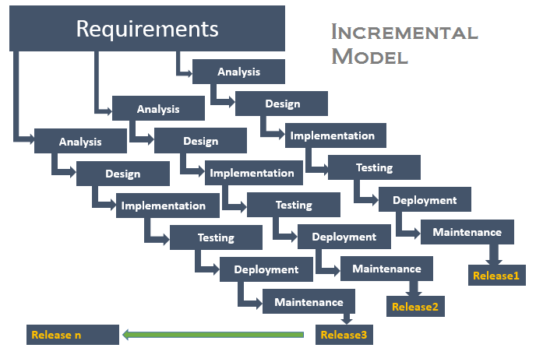Incremental funding is allowed, means only one or two increments might be funded when the program starts.

3.4 Functional Requirements of System: -

**(1) Hardware Requirement: -**

**Server Need:**

* Processor Intel Pentium IV(2.4GHZ)
* RAM: 512MB
* Hard Disk: 40GB
* NIC Card

**Client Need:**

* Processor: Intel core i3
* RAM:512 MB
* Hard Disk :100GB
* Internet Connection Required

**(2) Software Requirement: -**

**Client Need:**

* Operating System: Windows 7 and above.
* Browser: Google Chrome/ Mozilla Firefox.

3.2 System Requirement Specification: -

Table 3.2 System Requirement Specification

|  |  |  |  |  |
| --- | --- | --- | --- | --- |
| Actor | Main Activity | Database Activity | Activity in Table | Document |
|  |  |  |  |  |
| Admin | Add Faculty | Update | Clg_Faculty |  |
|  |  |  |  |  |
|  | Edit Faculty | Update | Clg_Faculty |  |
|  |  |  |  |  |
|  | Remove Faculty | Update | Clg_Faculty |  |
|  |  |  |  |  |
|  | Add images | Update | Clg_Gallery |  |
|  |  |  |  |  |
|  | Edit Images | Update | Clg_Gallery |  |
|  |  |  |  |  |
|  | Remove Images | Update | Clg_Gallery |  |
|  |  |  |  |  |
|  | Add Article | Update | Clg_Article |  |
|  |  |  |  |  |
|  | Edit Article | Update | Clg_Article |  |
|  |  |  |  |  |
|  | Remove Article | Update | Clg_Article |  |
|  |  |  |  |  |
|  | Add File to Download | Update | Clg_Download |  |
|  |  |  |  |  |
|  | Remove File to Download | Update | Clg_Download |  |
|  |  |  |  |  |

**Chapter-4**

**Design**

4.1 Data Flow Diagram

* 0 Level DFD

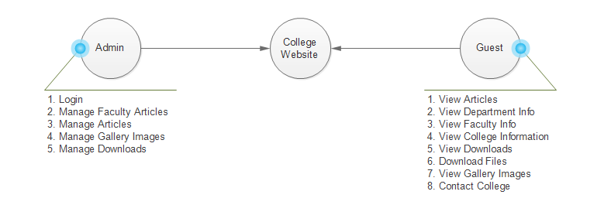

* 1st Level DFD Admin

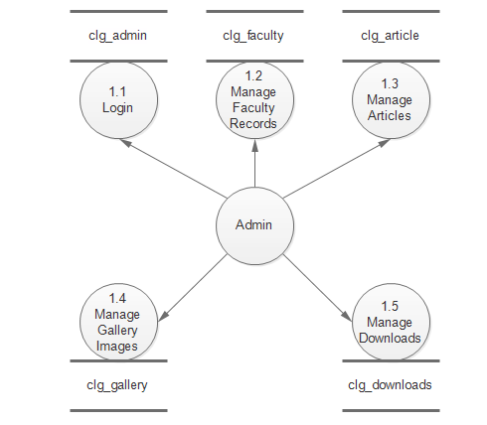

* 1st Level DFD Guest

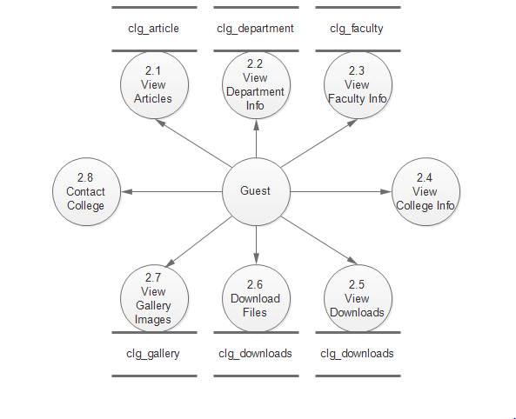

* 2nd Level DFD Manage Faculty Records

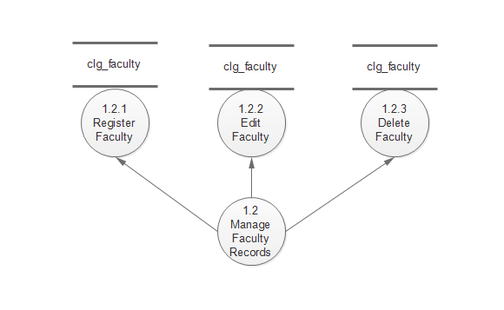

* 2nd Level DFD Manage Articles

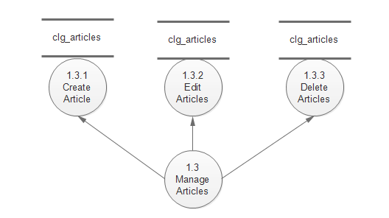

* 2nd Level DFD Manage Gallery Images

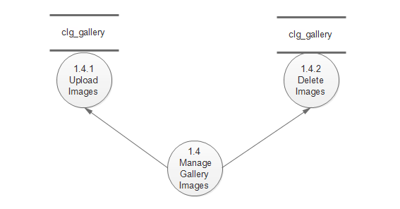

* 2nd Level DFD Manage Downloads

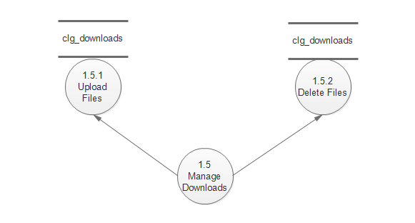

4.2 E-R Diagram

* E-R Diagram is a graphical tool to represent the model, and logical structure of database (Entity and Relationship exist among entity set)
* Components of ER Diagram: -
* Entity
* Attributes
* Relationship
* Key attributes
* There are two types of Entity: -

1. Strong Entity
2. Weak Entity

* Symbols:

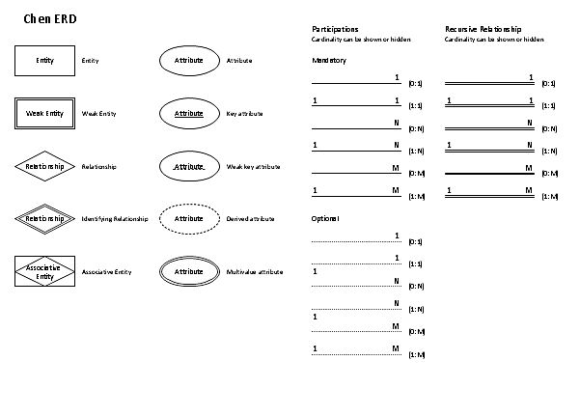

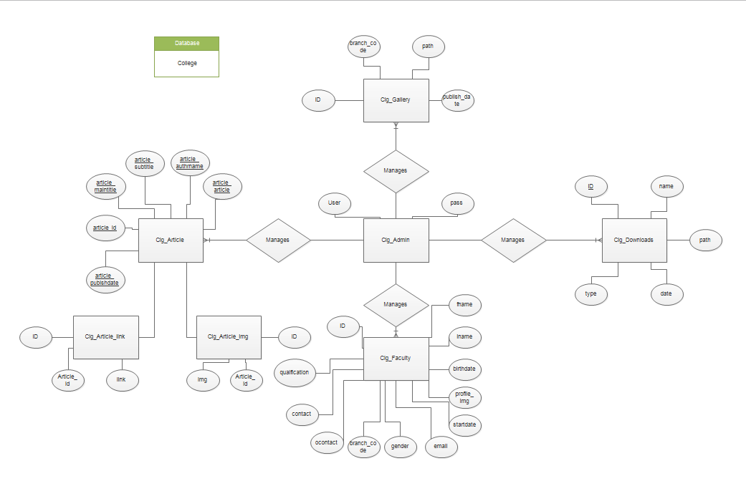

4.3 Data Dictionary

* Table 4.5.1 clg_Admin: -

|  |  |  |  |
| --- | --- | --- | --- |
| Column Name | Data Type | Size | Constraint |
| User | Varchar | 25. |  |
| Pass | Varchar | 25 |  |

* Table 4.5.2 clg_Gallery: -

|  |  |  |  |
| --- | --- | --- | --- |
| Column Name | Data Type | Size | Constraint |
| ID | Int | 11 | Primary key |
| Branch_code | Int | 10 |  |
| Path | Varchar | 100 |  |
| Publish_date | Date |  |  |

* Table 4.5.2 clg_Article: -

|  |  |  |  |
| --- | --- | --- | --- |
| Column Name | Data Type | Size | Constraint |
| ID | Int | 11 | Primary key |
| Maintitle | Varchar | 100 |  |
| Subtitle | Varchar | 100 |  |
| Article | Varchar | 2000 |  |
| Publishdate | Date |  |  |
| authorname | Varchar | 100 |  |

* Table 4.5.3 clg_article_link: -

|  |  |  |  |
| --- | --- | --- | --- |
| Column Name | Data Type | Size | Constraint |
| ID | Int | 10 | Primary Key |
| Article_id | Int | 10 | Foreign key |
| link | Varchar | 1000 |  |

* Table 4.5.3 Clg_article_img: -

|  |  |  |  |
| --- | --- | --- | --- |
| Column Name | Data Type | Size | Constraint |
| ID | Int | 10 | Primary Key |
| Article_id | Int | 10 | Foreign key |
| Img | Varchar | 1000 |  |

* Table 4.5.4 clg_faculty: -

|  |  |  |  |
| --- | --- | --- | --- |
| Column Name | Data Type | Size | Constraint |
| ID | Int | Auto Inc. | Primary key |
| Fname | Varchar | 50 |  |
| Mname | Varchar | 50 |  |
| Lname | Varchar | 50 |  |
| Gender | Boolean |  |  |
| Profile_img | Varchar | 2000 |  |
| Email | Varchar | 100 |  |
| Branch_code | Int | 2 |  |
| Post | Varchar | 15 |  |
| Qualification | Varchar | 50 |  |
| Contact | Int | 10 |  |
| Ocontact | Int | 10 |  |
| Birthdate | Date |  |  |
| Startdate | date |  |  |

* Table 4.5.5 clg_downloads: -

|  |  |  |  |
| --- | --- | --- | --- |
| Column Name | Data Type | Size | Constraint |
| ID | Int | 11 | Primary key |
| name | Varchar | 50 |  |
| Path | Varchar | 1000 |  |
| type | Varchar | 10 |  |
| Publish_date | Date |  |  |

Chapter-5

Implementation

And Testing

5.1 Black Box Testing

* The Functionality of the application was tested with the requirement specification.
* This was done to ensure that the functionality expected was captured as per the requirement specified.
* Also known as functional testing.
* We do not ever examine the programming code and does not need any further knowledge of the program other than is specifications.
* The internal functionality of the item being tested is not known by the tester.

5.2 White Box Testing

* This is basically done to ensure that he logic applied is correct and to check where the code fails.
* His is done knowing the logical flow of functionality and implementation
* White box testing is used because
  + Logic errors and incorrect assumptions are most likely to be made when coding “special case”. Need to ensure that these execution paths are tested.
  + May find assumptions about executions paths to be incorrect and so make design errors. White Box can pick these errors out.

Chapter-6

Graphical User Interface

6.1 Application Interface: -

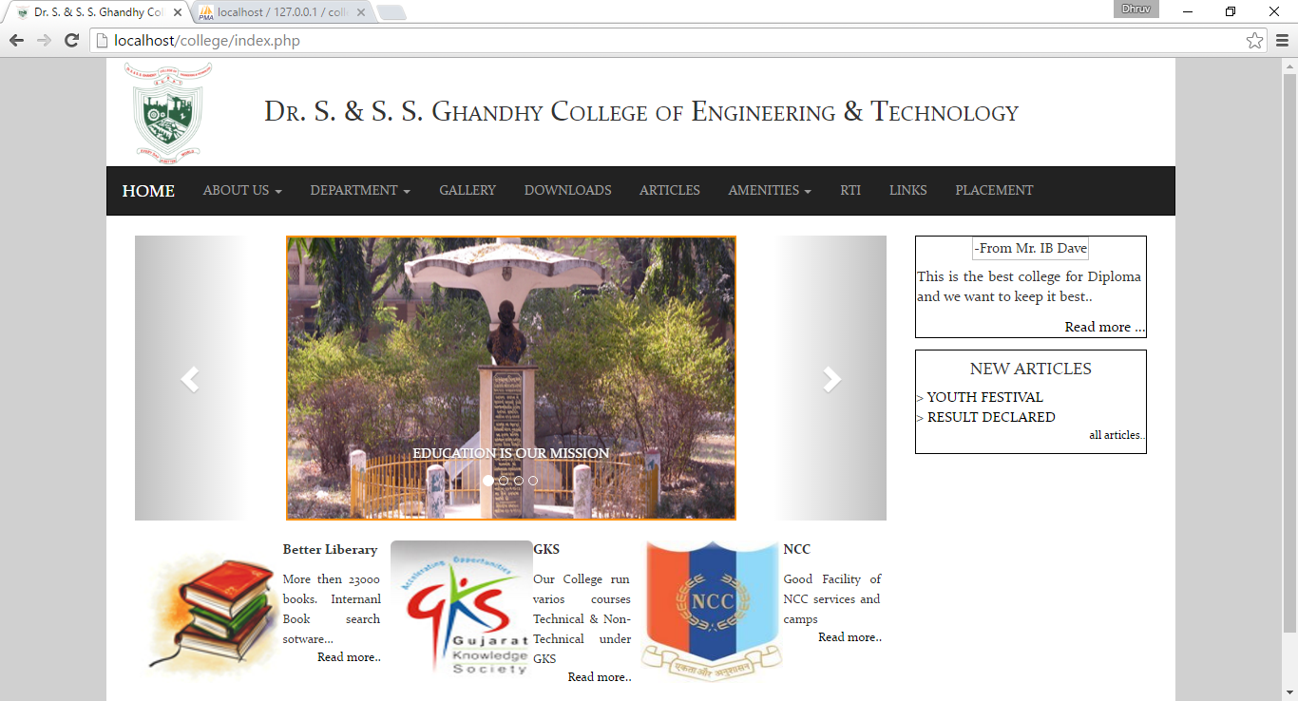

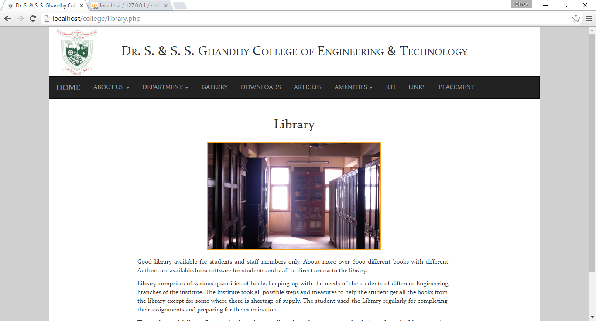

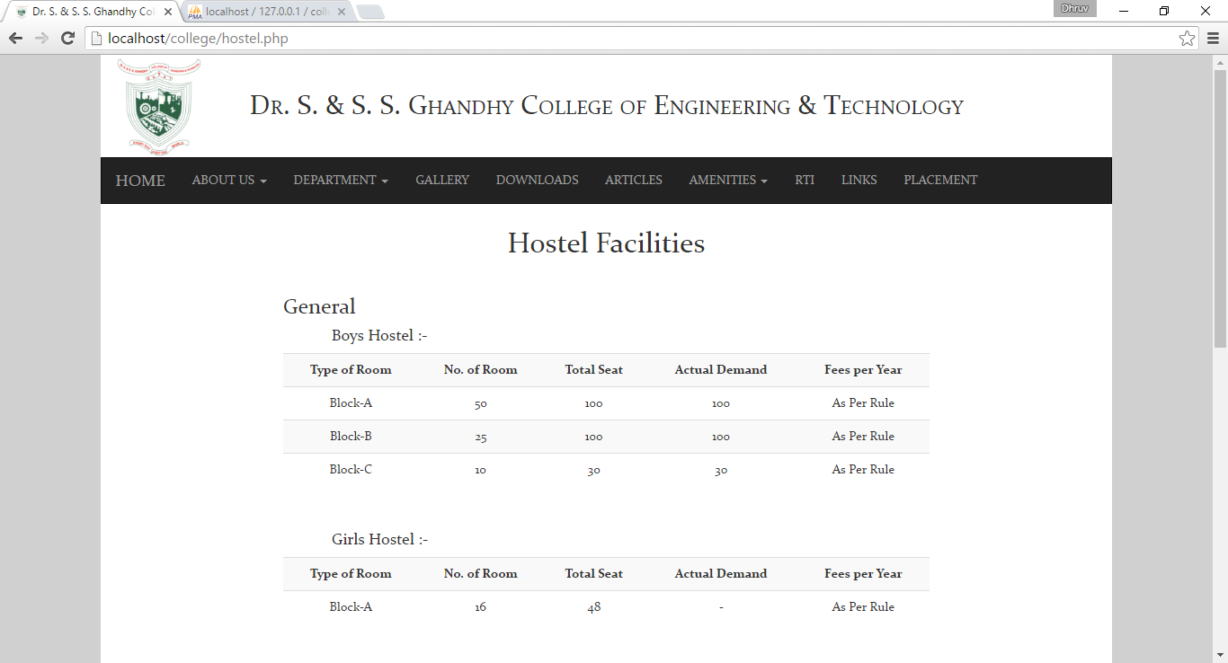

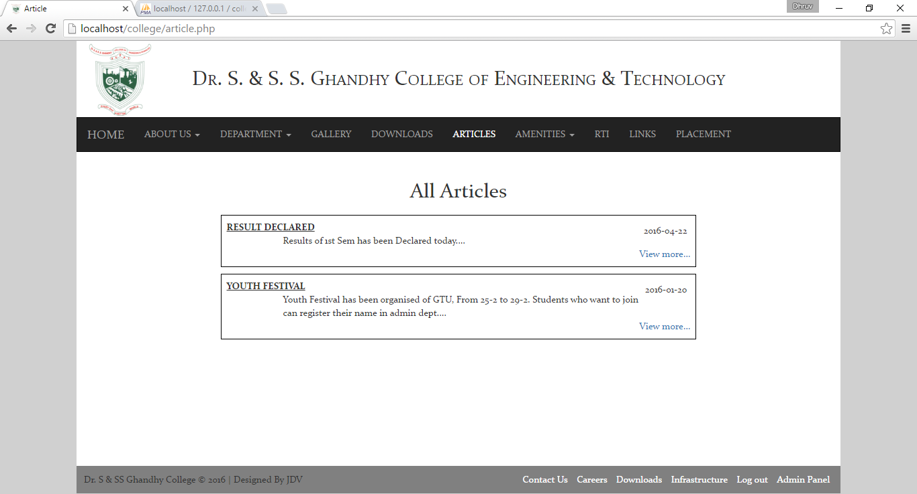

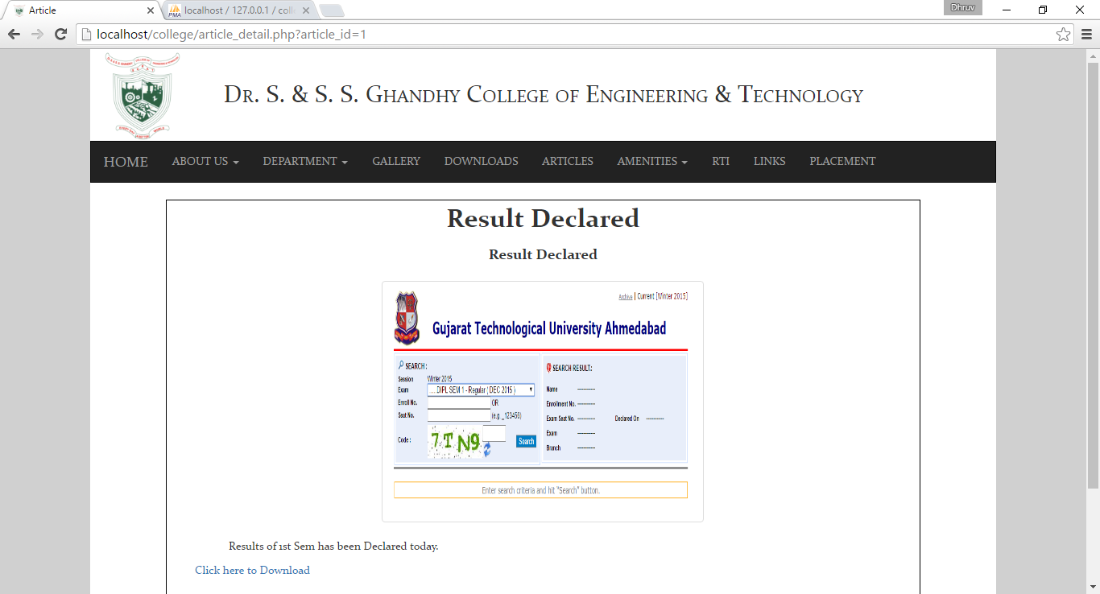

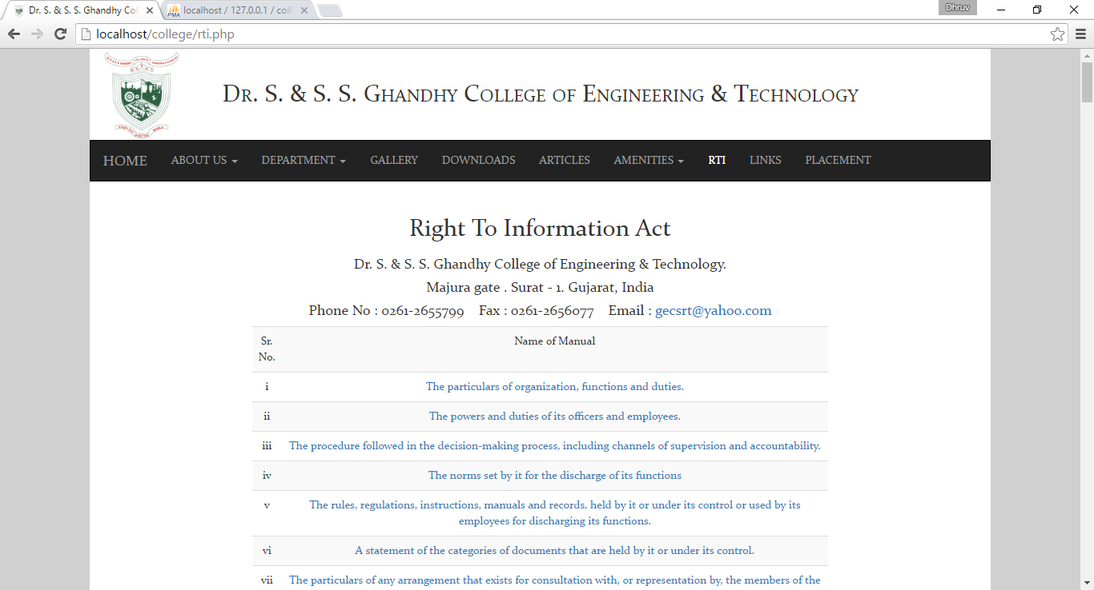

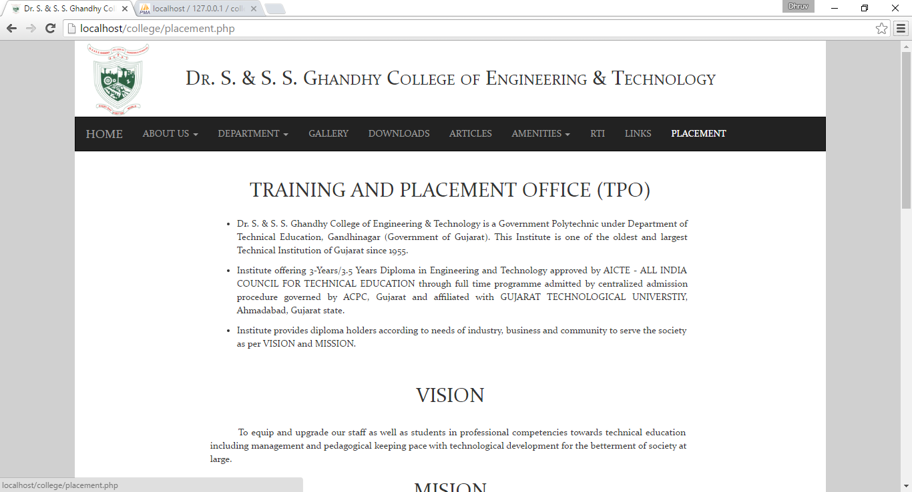

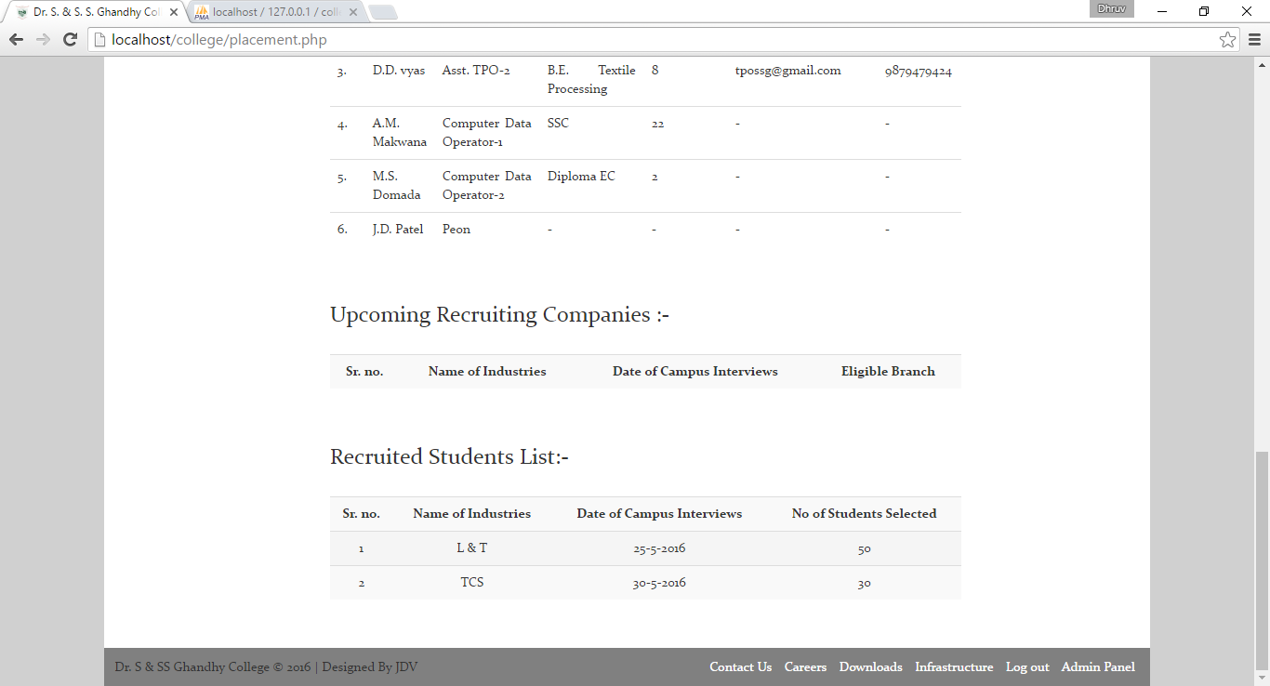

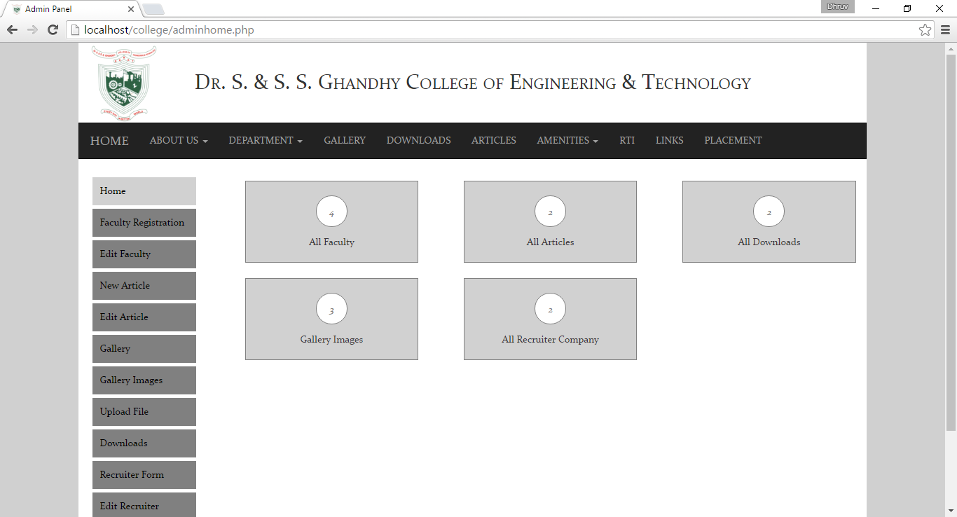

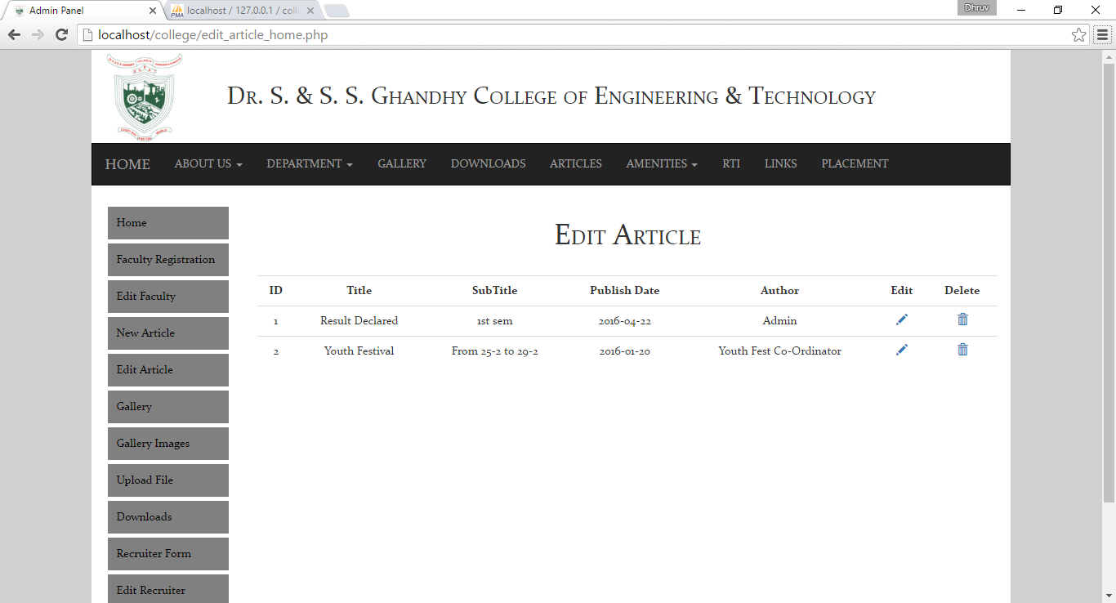

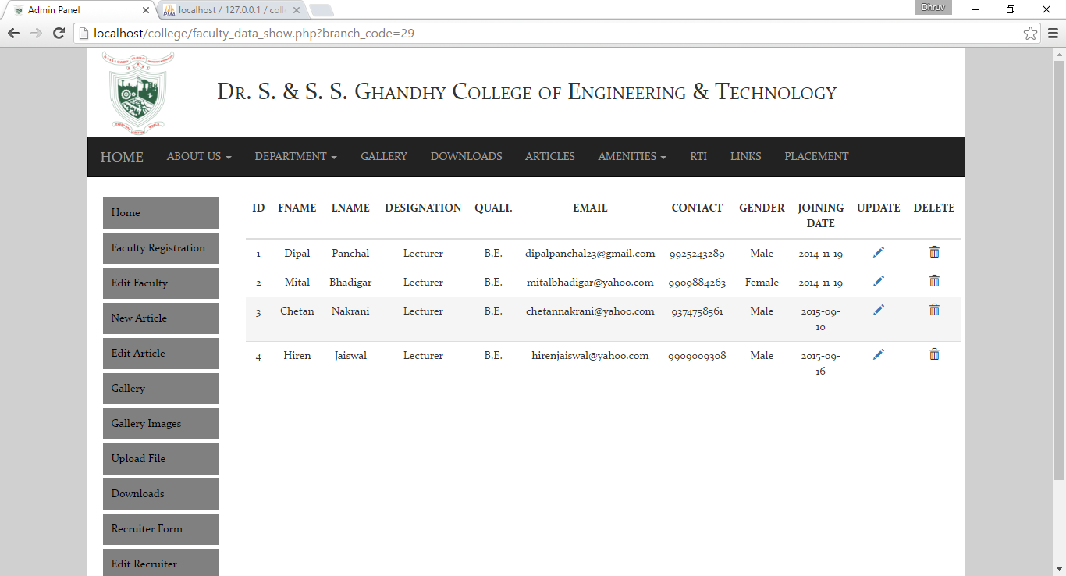

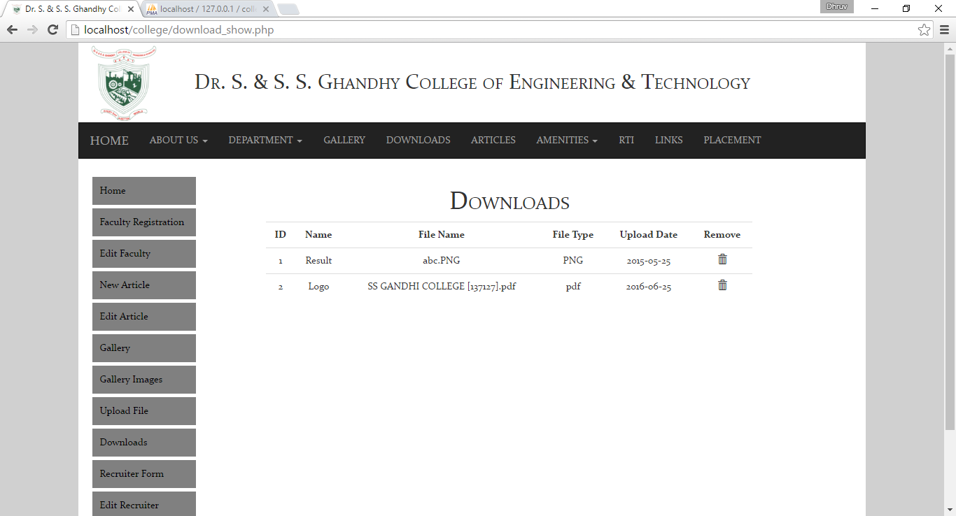

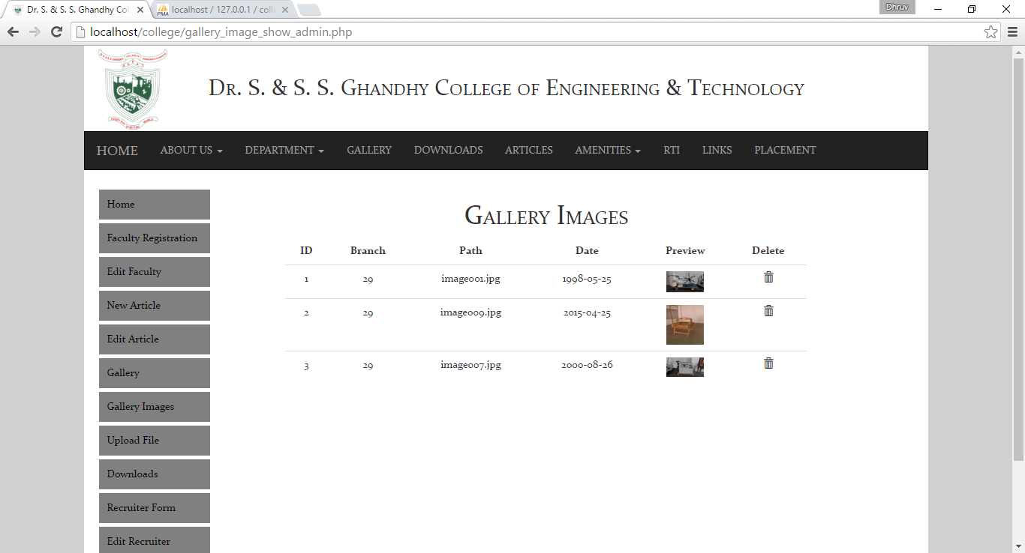

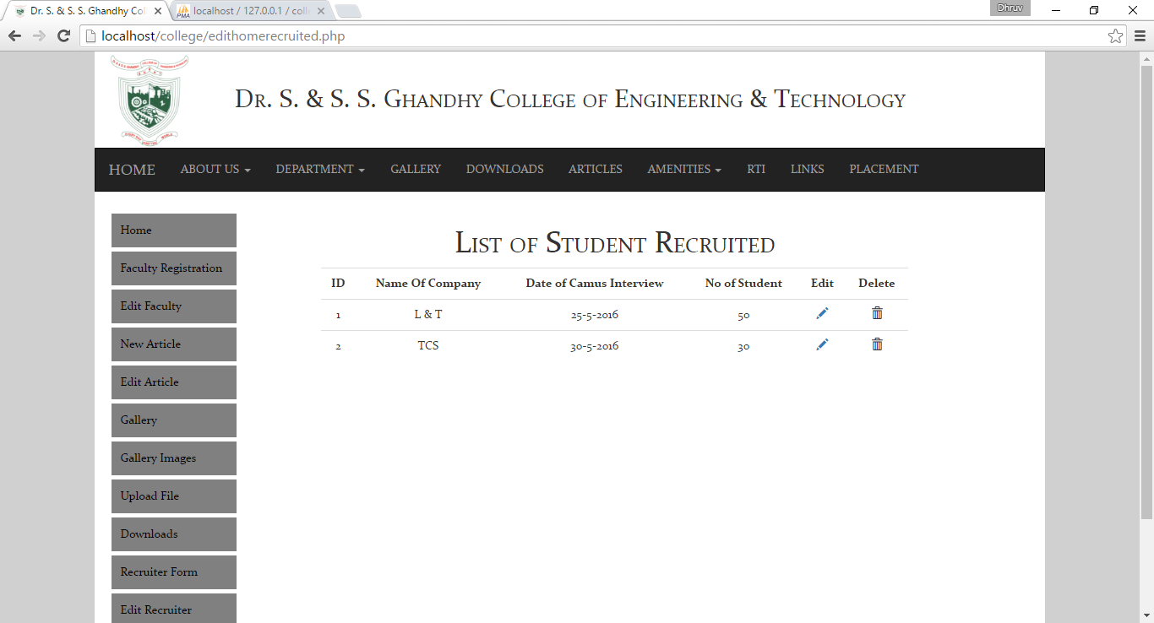

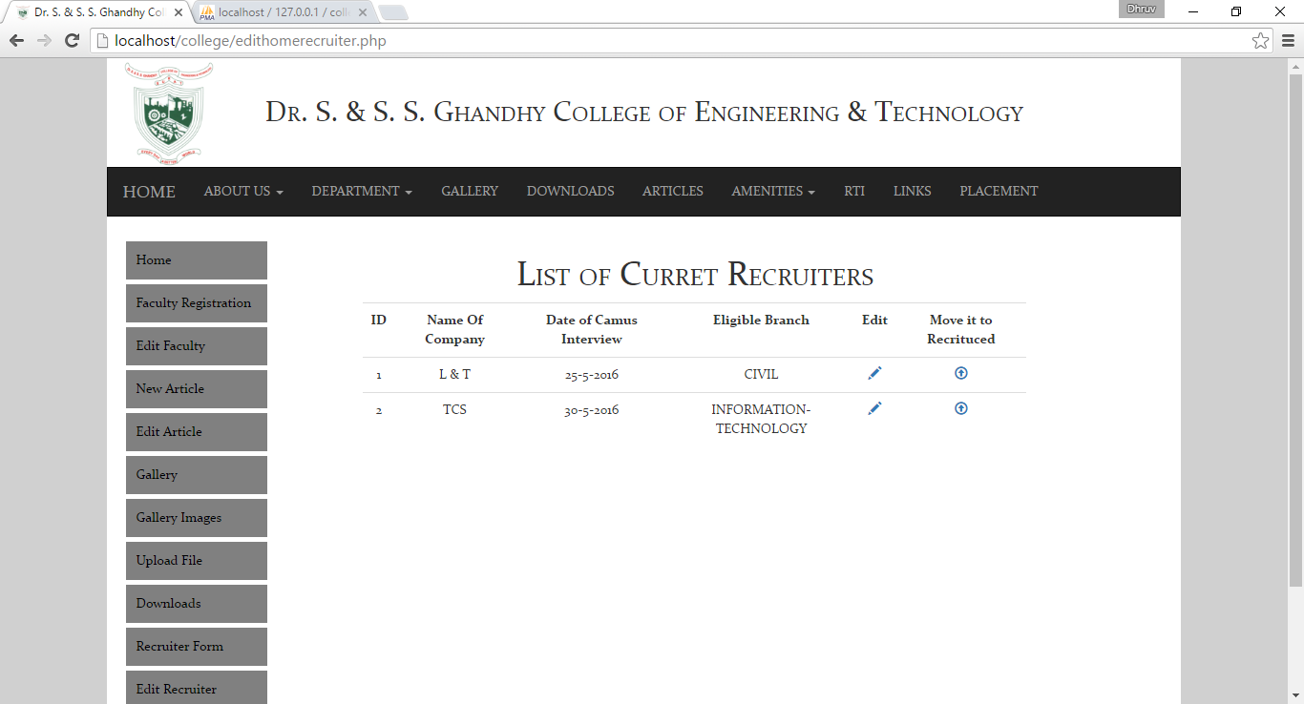

Chapter -7

Conclusion and

Future Work

7.1 Conclusion: -

* It is a Great Pleasure that the system is meeting most of its Requirements.
* Finally, we can conclude that this project is satisfying all its requirements of the user of website and it is satisfying all its objectives which were set at the time of development of website.

7.2 Advantages: -

* As it is upgraded to dynamic site, it will provide timely and up to date information and thus encourages readers to return to website.
* Single stop for all types of accurate and authentic college information which can serve as interactive medium for students.
* Having a dynamic college website allows to break through the geographical barriers and become accessible, virtually, from any country in world.
* Easy accessibility of information.
* Personal and career centric information from a broad spectrum of diploma professionals.
* Compatible with various screen size. (Responsive)

7.3 Limitation: -

* Results are not displayed.
* No compatible in Internet Explorer
* Student Login not supported
* E-mail services not provided.

7.4 Future Scope: -

* Results can be displayed.
* Students can be given login access and can interact with each other.
* Email services for students and faculties can be provided.

Chapter - 8

Bibliography

8.1 Books: -

* PHP with MY SQL
* PHP 5
* Dynamic Web Programming using PHP

8.2 Websites: -

* [www.w3schools.com](http://www.w3schools.com)
* [www.tutorialspoint.com](http://www.tutorialspoint.com)
* [www.getbootstrap.com](http://www.getbootstrap.com)